
Electric Conductivity of Soil

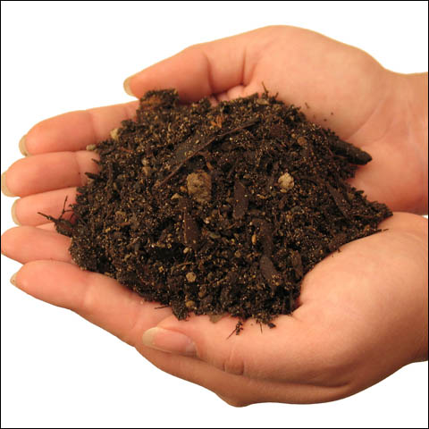
Soil electrical conductivity (EC) is a measurement that correlates with soil properties that affect crop productivity, including soil texture, cation exchange capacity (CEC), drainage conditions, organic matter level, salinity, and subsoil characteristics. Electrical conductivity (EC) is the most common measure of soil salinity and is indicative of the ability of an aqueous solution to carry an electric current. Plants are detrimentally affected, both physically and chemically, by excess salts in some soils and by high levels of exchangeable sodium in others.

The electrical conductivity of soils varies depending on the amount of moisture held by soil particles. Sands have a low conductivity, silts have a medium conductivity, and clays have a high conductivity. Consequently, EC correlates strongly to soil particle size and texture.

Electrical conductivity (EC) is the ability of a material to transmit (conduct) an electrical current and is commonly expressed in units of milliSiemens per meter (mS/m). Soil EC measurements may also be reported in units of deciSiemens per meter (dS/m), which is equal to the reading in mS/m divided by 100.

NevCAN and NCCP Data:

Nevada Climate-Ecohydrology Assessment Network (NevCAN) has two monitoring ranges that monitor the electric conductivity of soil. These basin-to-mountain top transects are located in the Sheep Range (located approximately 35 km NNW of Las Vegas) and in the Snake Range (east central NV along the UT border; approximately 335 km NNE of Las Vegas).

Measuring soil EC can be used to monitor regional climate change, soil fertility, and various factors like porosity, salinity, and possible crop fields.

